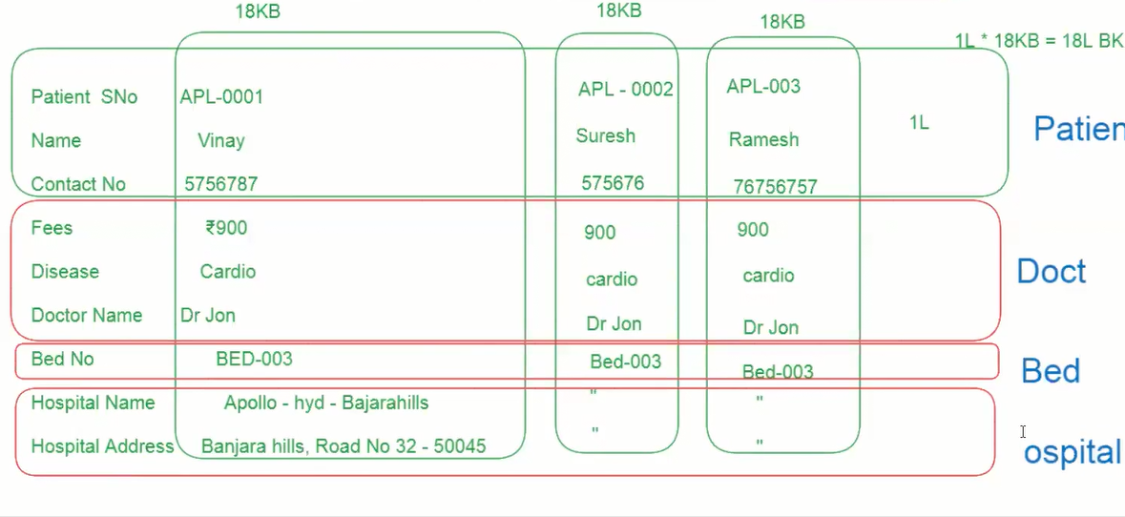

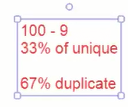

Data redundancy means duplicate data

The connection between the 2 objects is called a relationship

To reduce data redundancy.

Relationship into 2

1. Optional Relationship
2. Required / mandatory Relationship

Option relationship is nothing, but the object may require or not for relationship.

Required or mandatory means this object is 100 percent required for relationship.

1. Optional Relationship
2. Lookup relationships
3. Required / mandatory relationships
4. Master detail relationship

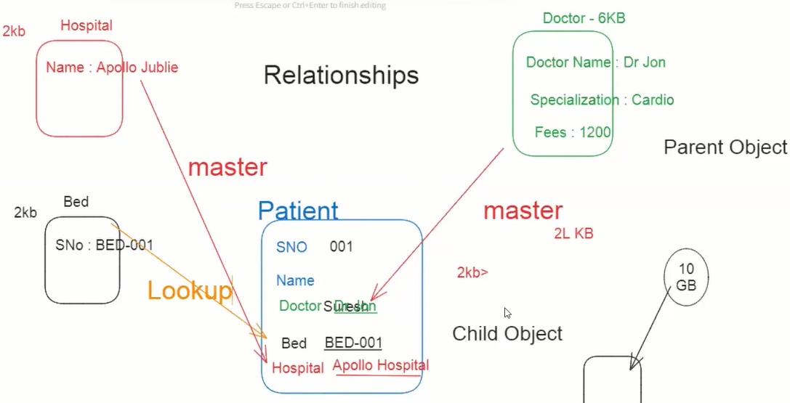

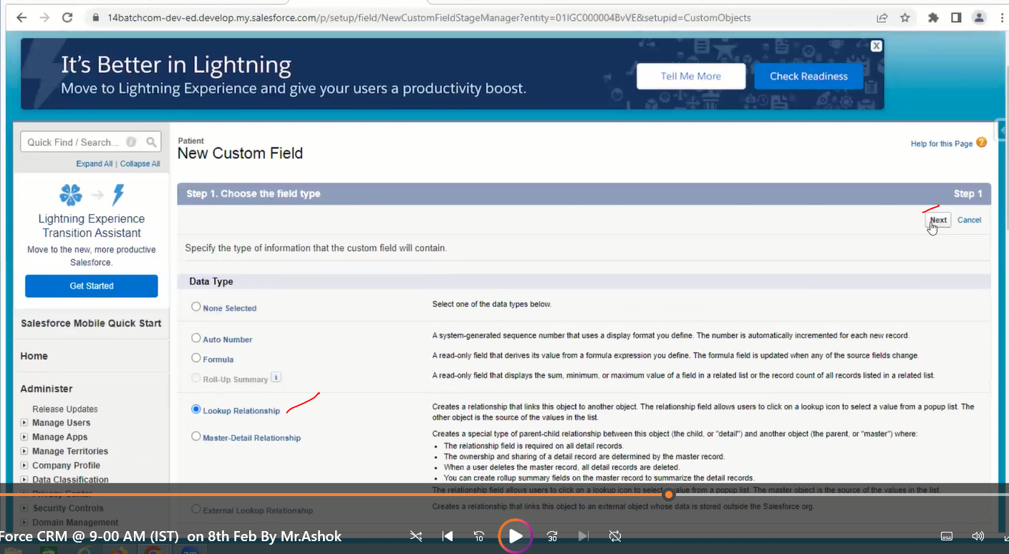

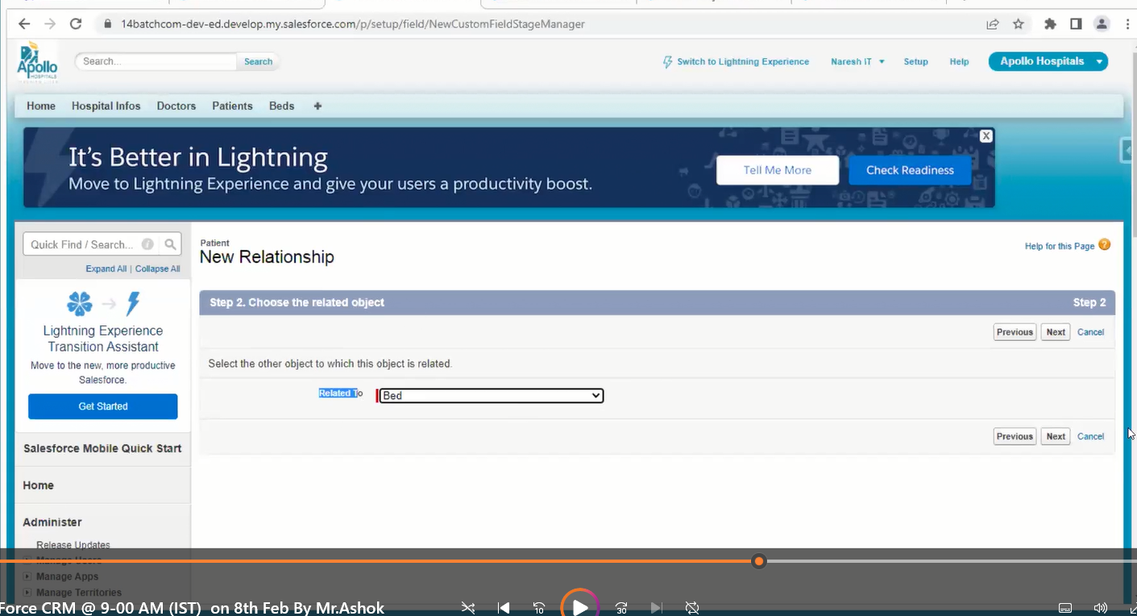

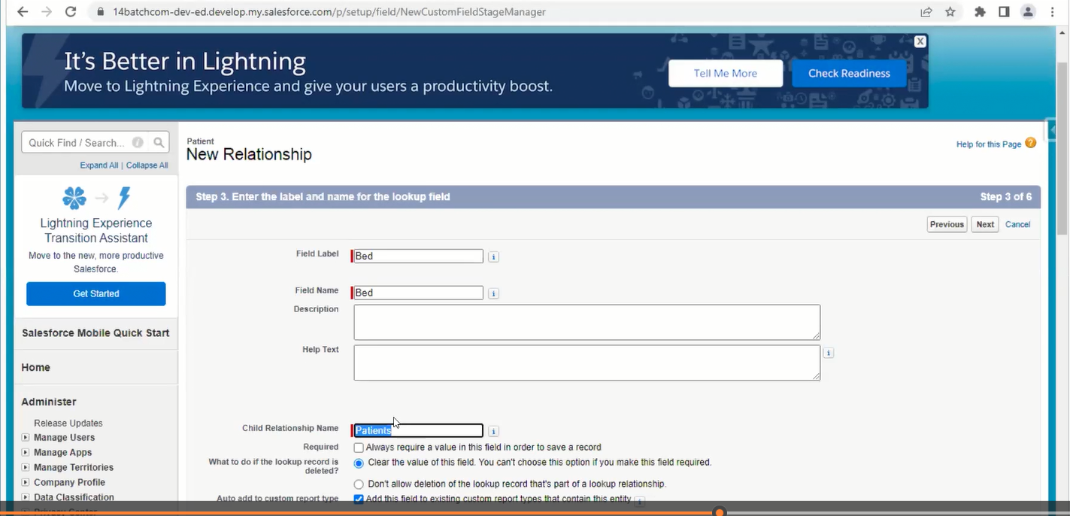

Reason



While creating master-detail relationships we need to create and add data.

In the above case we have 2 options to create master relationships.

Case 1

Remove all the records of child and create (not recommended)

Case 2

Next class

Runtime engine